**Me llamo:___________________________________________________________________________________**

**Buen Viaje I, capítulo 9**

**Parte A: Identify the following nouns. Write the vocabulary word pictured below. Be sure to include its definite article. Follow the model…**

MODEL:   **Las botas**

1. 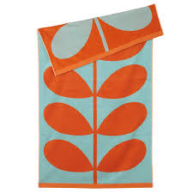 __________________________________________ 2. 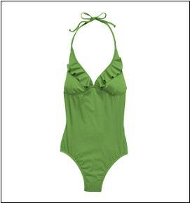 ________________________________

3. 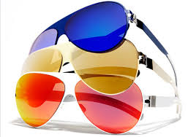 ____________________________________________ 4. 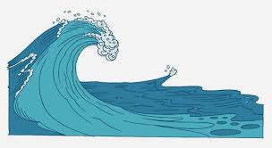 ______________________________

5. 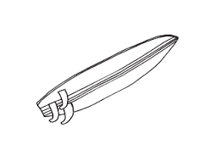_________________________________________ 6. 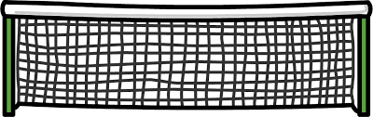 ______________________

7. 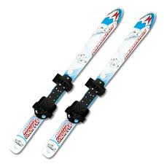 ______________________________________________ 8. 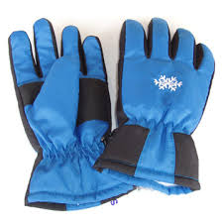__________________________________

9. 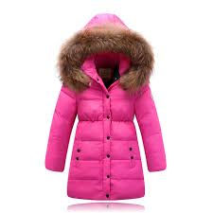______________________________________________ 10. 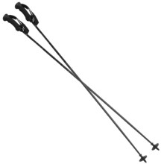______________________________

**Parte B: Identify the following verbs. Follow the model…**

MODEL:  **esquiar**

1. _______________________________________________ 2. __________________________________

3. 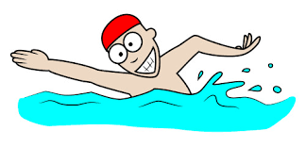______________________________________ 4. 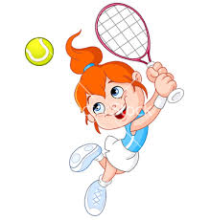_______________________________

5. 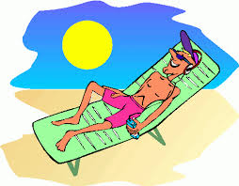_________________________________________ 6. 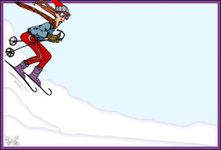___________________________

_____________________________________________

(three words)

**Parte C. Choose where the activity would normally take place. It may be in more than one place.**

|  |  |  |  |  |
| --- | --- | --- | --- | --- |
| # | Playa | Estación de esquí | Cancha de tenis | Piscina |
| 1. practicar el surfing |  |  |  |  |
| 2. jugar singles |  |  |  |  |
| 3. comprar boletos para el telesilla |  |  |  |  |
| 4. Practicar el surfing |  |  |  |  |
| 5. Bajar la pista |  |  |  |  |
| 6. tomar el sol |  |  |  |  |
| 7. Subir en el telesilla |  |  |  |  |
| 8. nadar |  |  |  |  |

**Parte D:** **Sinónimos. Fill in the blank with the correct vocabulary word that means the same thing.**

1. El bañador (bathing suit) ___________________________________________________________________________.

2. Los anteojos de sol ___________________________________________________________________________________.

3. La piscina______________________________________________________________________________________________.

4. Hay sol_________________________________________________________________________________________________.

5. El ticket ________________________________________________________________________________________________.

7. La boletería ____________________________________________________________________________________________.

8. Nieva ___________________________________________________________________________________________________.

9. Está lloviendo__________________________________________________________________________________________.

**Parte E: Regular verbs in the present tense. Make a verbs chart for the following verbs. Follow the model.**

To scuba dive = bucear

|  |  |
| --- | --- |
| Yo buceo = I scuba dive or I am scuba diving | Nosotros / Nosotras buceamos = We scuba dive or we are scuba diving |
| Tú buceas = You (ppffk) scuba dive or you (ppffk) are scuba diving | **XXXXXXXXXXX** |
| Ud. / Él / Ella bucea = You (fs.), he/she (any one name or thing) scuba dive or are scuba diving | bucean = You (pl.) they scuba dive or are scuba  diving |

To ski = ____________________________________________

|  |  |
| --- | --- |
| Yo | Nosotros / Nosotras / Any one (or more names) y yo |
| Tú | **XXXXXXXXXXX** |
| Ud. / Él / Ella / (One name or collective singular subjects like Marta OR Mi familia) | Uds. / Ellos / Ellas / Two (or more names, like Ana y Paco) |

To swim = ___________________________________________________

|  |  |
| --- | --- |
| Yo | Nosotros / Nosotras / Any one (or more names) y yo |
| Tú | **XXXXXXXXXXX** |
| Ud. / Él / Ella / (One name or collective singular subjects like Marta OR Mi familia) | Uds. / Ellos / Ellas / Two (or more names, like Ana y Paco) |

To take (as in to sun bathe) = ____________________________________________________

|  |  |
| --- | --- |
| Yo | Nosotros / Nosotras / Any one (or more names) y yo |
| Tú | **XXXXXXXXXXX** |
| Ud. / Él / Ella / (One name or collective singular subjects like Marta OR Mi familia) | Uds. / Ellos / Ellas / Two (or more names, like Ana y Paco) |

To practice = _____________________________________________________

|  |  |
| --- | --- |
| Yo | Nosotros / Nosotras / Any one (or more names) y yo |
| Tú | **XXXXXXXXXXX** |
| Ud. / Él / Ella / (One name or collective singular subjects like Marta OR Mi familia) | Uds. / Ellos / Ellas / Two (or more names, like Ana y Paco) |

To go down (the ski slope) = _______________________________________________________

|  |  |
| --- | --- |
| Yo | Nosotros / Nosotras / Any one (or more names) y yo |
| Tú | **XXXXXXXXXXX** |
| Ud. / Él / Ella / (One name or collective singular subjects like Marta OR Mi familia) | Uds. / Ellos / Ellas / Two (or more names, like Ana y Paco) |

To play (a sport) = ___________________________________________

**(IOjo! This is a stem-changing verb; aka “boot verb”)**

|  |  |
| --- | --- |
| Yo | Nosotros / Nosotras / Any one (or more names) y yo |
| Tú | **XXXXXXXXXXX** |
| Ud. / Él / Ella / (One name or collective singular subjects like Marta OR Mi familia) | Uds. / Ellos / Ellas / Two (or more names, like Ana y Paco) |

To go up (the ski slope or in the ski lift) = ___________________________________________________

(**iOjo! This is an –ir verb. It takes regular –ir verb endings)**

|  |  |
| --- | --- |
| Yo | Nosotros / Nosotras / Any one (or more names) y yo |
| Tú | **XXXXXXXXXXX** |
| Ud. / Él / Ella / (One name or collective singular subjects like Marta OR Mi familia) | Uds. / Ellos / Ellas / Two (or more names, like Ana y Paco) |

**Parte F: Translate the following sentences into Spanish.**

1. I am scuba diving in the sea.____________________________________________________________________________________

2. Paco and Ana are playing tennis_______________________________________________________________________________

3. We are going up the ski slope in the ski lift

____________________________________________________________________________________________________________________

4. You (pl.) are sun bathing________________________________________________________________________________________

5. My family is swimming in the pool._____________________________________________________________________________

6. Roberto and I are going down the expert slope._______________________________________________________________

7. They are not playing because it is raining.______________________________________________________________________

**Parte G: Describe what you see in the picture below. Write 7 sentences. It is perfectly acceptable to use verbs from previous chapters (such as comer or leer). Further, you can describe the weather and make inferences (describing what could be happening; even though it is not pictured) if you wish. For instance, you could say that people are scuba diving even though you do not see that activity in the picture.**

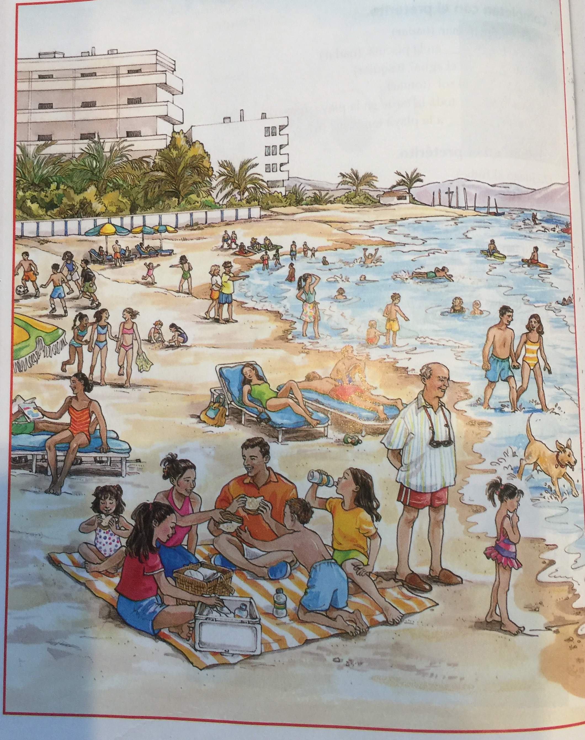

**1.______________________________________________________________________________________________________________________**

**2.______________________________________________________________________________________________________________________**

**3.______________________________________________________________________________________________________________________**

**4.______________________________________________________________________________________________________________________**

**5.______________________________________________________________________________________________________________________**

**6.______________________________________________________________________________________________________________________**

**7.______________________________________________________________________________________________________________________**