El Vocabulario, Buen Viaje II, capítulo 3
Describing a Computer:
- la computadora / el ordenador = _____________________________________________
- el teclado = _____________________________________________________________
- el monitor / la pantalla = ___________________________________________________
- el disquete = ____________________________________________________________
- el ratón = _______________________________________________________________
- la impresora = ___________________________________________________________
- la ranura = ______________________________________________________________
- el correr electrónico = _____________________________________________________
- el CD-ROM = ___________________________________________________________
- el internet = _____________________________________________________________

Describing computer activities:
- prender la máquina = _____________________________________________________
- meter un disquete = ______________________________________________________
- entrar los datos = ________________________________________________________
- hacer las tareas = ________________________________________________________
- guardar = ______________________________________________________________
- comunicarse = __________________________________________________________
- terminar = _____________________________________________________________
- apagar = ______________________________________________________________
- sacar = ________________________________________________________________

Describing how to send a fax:
- el facsimile / el fax = ____________________________________________________
- el aparato = ___________________________________________________________
- el documento = _________________________________________________________
- boca arriba = __________________________________________________________
- boca abajo = __________________________________________________________
- mandar / transmitir = ___________________________________________________
- meter = ______________________________________________________________
- pulsar el botón = _______________________________________________________

Describing a telephone:
- el teléfono publico = ____________________________________________________
- la ranura = ___________________________________________________________
- el auricular = _________________________________________________________
- el disco = ____________________________________________________________
- el teléfono de botones = _________________________________________________
- el teléfono celular = ____________________________________________________
- la tecla = _____________________________________________________________
- el contestador automático = _______________________________________________
- dejar un mensaje = ______________________________________________________

Describing telephone numbers:
- la guía telefónica = ______________________________________________________
- el prefijo de país = _______________________________________________________
- la clave de area = ________________________________________________________
- el número de teléfono = ___________________________________________________

Making a telephone call:
- hacer una llamada telefónica = ______________________________________________
- llamar = ________________________________________________________________
- descolgar el auricular = ____________________________________________________
- introducer la tarjeta telefónica = ____________________________________________
- oír el tono = _____________________________________________________________
- marcar el número = _______________________________________________________
- sonar = _________________________________________________________________
- contestar = ______________________________________________________________
- ¿Está…? = ______________________________________________________________
- ¿De parte de quién? = _____________________________________________________

Other useful expressions:
- a menudo = ____________________________________________________________
- con frecuencia = ________________________________________________________

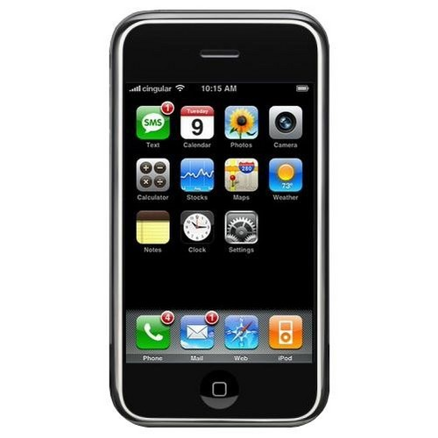
No uses el teléfono celular en clase, por favor

