Me llamo:____________________________________________________________________

Present Progressive Translations:

Directions: Translate the following into Spanish…

1. The plane is landing_________________________________________________________

2. The passengers are claiming their luggage
___________________________________________________________________________

3. They are disembarking_______________________________________________________

4. He is inspecting the suitcases__________________________________________________

5. I am passing through the security check (pasar = to pass)
____________________________________________________________________________

6. The agent is checking the ticket.________________________________________________

7. The men are taking a flight____________________________________________________

8. The flight crew is boarding the plane.____________________________________________

9. The family is taking a trip.______________________________________________________

10. We are opening the suitcases._________________________________________________

11. The flight is not leaving on time________________________________________________

12. The taxi is arriving to the (al = to the) airport_____________________________________

13. Are you checking the luggage?_________________________________________________

OVER->

Directions: Using the present progressive tense, describe the following pictures…

1. La asistente de vuelo_____________________________________el café.

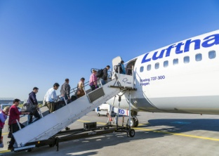 2. Los pasajeros_________________________________________el avión.

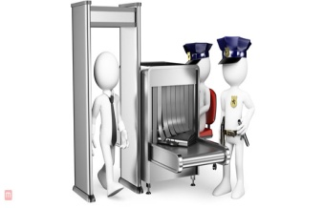3. Yo _________________________________________________por el
control de seguridad.

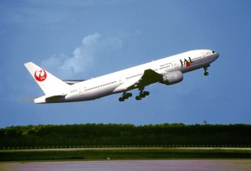 4. El avión ______________________________sin demora.

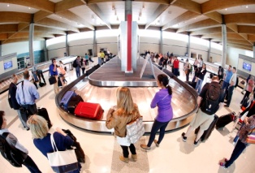 5. Tú___________________________________________ el equipaje.

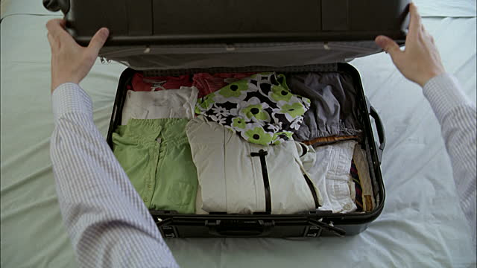 6. El agente de aduana ______________________________la maleta.

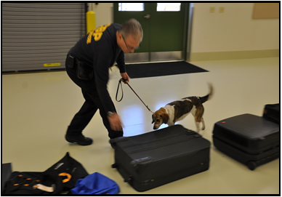7. El perro _________________________________________el equipaje.

